Name: Fuli Fuli
Student id: 3613005
UPI: Jful017
BTECH451A Report
Supervisor: Mano Manoharan

Modelling enterprise scale security architecture using threats
Threat Modeling for web architecture designs:

Part 1:

ABSTRACT
occur, and the numbers of computers/users that gets added to the network, grows at a rate that security cannot keep up with and opens up the floodgates to breaches, hackers and other From most of the literature on security modeling and architecture and from what is presented in slides and other sources of information on the subject, it is evident that it is universally accepted and known that security teams have a huge tactical disadvantage when it comes to defending against malicious threats to the network[2][9][8]. It is widely acknowledged that security teams are always a step, or several steps, behind the hackers or threat agents (as they are also called)[9]. The security teams are often more of a reactionary measure to breaches rather than a preventative measure in this day and age[9]. The speed at which advances in internet technology threats[8]. One of the key disadvantages that security teams have is that the systems they protect are designed with security as an afterthought[2]. Furthermore, cloud architecture increasingly makes traditional defence in depth defences obsolete, so the task of making a network secure becomes even more of a daunting challenge[9]. This is where the concept of threat modeling can be used to help aid security teams and web architects. At the basic core of its methodology is the idea that systems can be built with security in mind and hence create a network, application, system that is more resilient to threat agents of all type. Microsoft have developed this threat modelling methodology over the past decade and now have a 2016 version of a tool that can be used to model a prospective design or system structure, and assess its vulnerabilities to threats at the conceptual design stages[3]. This will lead to bugs and design defects being captured and fixed before deployment. There are other types of threat models but this report will focus primarily on the microsoft STRIDE modeling tool.
Table of Contents:

Introduction:

1)Current day situation

2)Traditional Role of Threat Modeling tools

3)Aim of Project

Main body of Report:

- Defining a Threat Model

1a) Venn diagram

2) STRIDE:

3) Other Threat Models-(compared and contrasted)

4) Microsoft modeling tool- (STRIDE based tool)

Btech451A Project

5) Real world application- Applying threat modeling to web architecture

6) STRIDE based gap analysis on a solution model

7) Preliminary results and recommendations

Conclusion
Acknowledgements:

Bibliography
INTRODUCTION:
Current day Situation:
The dawn of the internet age saw the dawn of a new age in human history. Business models have changed due to the emergence of new internet technologies. Cyber crime also arose out of this age on a massive scale. This is due in no small part to design of the network which basically connects every computer globally, to a single network where all information is digitised[8]. It is no surprise to many leading security experts that criminals quickly adapted to this technology and were able to exploit holes in the defense systems which were applied as more of an afterthough[8]t.

One security tech expert compared it to bringing back raiding and pillaging at a level we haven’t seen in centuries, where criminals can operate at an ultra large scale with little probability of being caught or punished for their crimes[8]. Many acknowledge that legislation is also lagging behind this internet technology boom and this also contributes to lack of prosecution as different countries have different laws, and we then also have different jurisdictions as online crimes can occur in any part of the world and yet originate from any part of the world (eg: someone can commit a cybercrime in New Zealand, but perpetrate the crime from a PC whilst sitting in Germany). Changes in law are a slow process that also cannot keep pace with the rapid rise in the Internets technological capabilities[8].

This tech expert uses the analogy of a leaky boat design to describe the security model for the growing internet network, and says that instead of fixing the leaks, we are building bigger boats, and exponentially more of them, with more bells and whistles, that carry more people at an ever increasingly faster rate[8]. He goes on to compare the efforts of security teams with emergency helpers who are brought in with a bucket to bail water out of the boat when it gets to a critical point, rather than being asked to help fix the leaks, and fix the design of the boat[8]. To use yet another analogy, we could say modern network security teams are presently seen as the proverbial ambulance at the bottom of the cliff. The clean up crew bought in to clean up the mess after the fact.

Sun Tzu quote, “Know thyself and know thy enemy and you need not fear the result of a hundred battles”. This wise old chinese general lived centuries ago, but his wisdom and tactical nouse is still used in warfare, politics and business to this day and it is also used in security. Good security strategy would mean we need to know our own security strengths and weak-points in order to know ourselves.

Threat models such as STRIDE can help us to do this and to also understand/know our enemy, so that we can organize a planned tactical response to threats, and even anticipate the enemy agents response[2]. This can help enable security teams to be less of a reactionary measure to security breaches in this internet modern age, and more of the proactive preventative measure that security has always traditionally meant to be, as seen in other fields of security other than network security. Threat modeling philosophy hinges on the idea that incorporating threat modeling processes into the architectural stages of the designs, will lead to a better design that is more resilient to threats and attack agents[2].

Traditional Role of Threat Modeling Tools- use for web architecture
The role of security and solution web architecture is often a two step process whereby the designers create a solution design and then the design is given a thorough security check by the security team to check vulnerabilities within the design that could lead to threat agents gaining access to the application, server or network. Based on the feedback from the security review, if deemed necessary, the design will need to be amended in order to address the concerns. This process can be simplified with the use of threat modelling tools[2].

The job of the threat modeller tool is to evaluate all possible threats and residual risk within a solution design and make recommendations for mitigations and/or its possible restructuring to the designers. This would also be a useful process as it allows them to mould their architecture with security in mind[3]. One of the main issues security has always had with the way in which a network is designed, is that security is more of an afterthought and this can lead to increased vulnerability to threats and hacker agents[1]. The tool should assist in avoidance of this problem.

This is not to say that the web architects are in any way at fault, as it is common practice in most organisations for architectsto simply design and then have security do their checks as a two step process. Also, designers are more solution focussed and so it is their main priority to design and find a way to solve a problem. Their KPIs are based on this goal, so just for clarity, this report is not in any way a form of criticism on current architectural practices as being deficient. It is about presenting an option/tool that is simple and easy to use, and that could be of benefit to both the architecture and security teams by the incorporation of threat modelling with STRIDE into architectural practices[4].

The ultimate aim of the project, by the end of the year, is to give a tool/process that systematically captures threats and results in “less work” for both the architectural and security teams in any I.T organisation. To achieve this ideal goal, we are looking to make the process fit seamlessly into the already well established current practices that exist, rather than introduce a superfluous process that results in more work or more red tape for those involved. This can only be achieved successfully if the process is kept as simple as possible and is developed with input from both sides(Security and Architecture).

Aim of the Report:
My report will compare and contrast the emerging advancements in threat modelling used in the security industry today, and categorise the commonalities and differences in techniques used. It will also apply the STRIDE based model to the University of Auckland(UOA) architecture to assess and identify the threats that we face on a daily basis, outline the stakeholders involved, which ultimately aims to give well informed recommendations for enhancement of the current architectures best practices. This will be achieved by analysis of security and logging patterns, and a more comprehensive understanding of possible threats and residual risk that may currently be present in the architecture. By the projects end, we should have a practice that systematically captures threats and can be useful to all security based network teams in a wider context, from the design planning stages, to deployment, to operations delivery where threat modelling can be integrated at all of these stages of the process in order to strengthen network security architecture.

MAIN BODY OF REPORT:

- Defining a Threat Model:

“Just what is a threat model?” is a typical question one may encounter when the topic of threat modeling is raised. It may seem like a fancy term denoting some complex methodology, but actually threat modeling is just a term for something we do intuitively on a regular basis[2].
When we are walking down the street at night we cross the street if we see a group of rowdy drunks approaching, or may stay in lighted areas to minimise chances of being mugged or attacked.

When we park our cars at night in a shopping mall or at the movies, we might want to park in a busy well lit area close to security cameras or security personnel, and we would ensure the doors and windows are locked and may even use a highly visible wheel brace and a bumper sticker advertising a car alarm(whether you have one or not) to ward off or discourage car thieves. You might also assess what items you want to leave in the car, at risk of being taken, and which are so valuable that you cannot risk loss so must take with you if possible. You are threat modeling for your car.

As Shostack states, if you were to threat model for your house you may begin thinking about valued items in your house worth protecting, 50 inch plasma TV, jewelry, family heirlooms, family pictures, safe, your priceless comic book collection etc[2]. You might even think about hiding your most valuable assets in a hidden safe or hidden space within your house. You would start thinking about ways burglars could gain entry to your house, and what you can do to secure it, such as locking doors, windows, maybe setting up an alarm and/or building a perimeter fence with a guard dog(s) to protect the property[2]. You may even begin thinking about the types of intruders who may try to break in, pro cat burglars, neighbourhood kids, stalkers, home invasion criminals, crazed drug addicts[2] and assessing level of your security based on the most likely threats in your neighbourhood.

By threat modeling for your car or your house, you are assessing all possible threats that you may encounter and taking steps to minimise or mitigate against these threats. You are also assessing your assets and deciding which ones are most important and require more security. Finally, you are assessing the type of threats agents that you would most likely encounter and thinking about finding the appropriate level of security needed to counter that threat. All of these scenarios have an analogous counterpart in the IT world[2]. It is important for now to just relate to the type of thinking that goes into threat modeling[2].

Threat modeling for ourselves, our car or our house may seem intuitive but If we were asked to threat model for a prison or a large company, this would be far more difficult and we would no longer trust in the completeness of our own analysis[2]. We would need tools to make this job easier. Threat modeling gives users the tools to begin thinking about structured security in an easy and effective way, that is instinctive and intuitive, much like the analogies presented here[3].

We can also look at another analogy presented by Shostack, a leading authority on threat modeling. Rather than protecting a house, as in the previous analogy, let us think of ourselves as architects who are in the process of designing and building a house[2]. One childhood story that comes to mind and is quite relevant to this, is that of the three little pigs and the big bad wolf. One architect builds his house out of straw, another architect builds his house out of sticks, the third architect builds his house out of bricks. They all have a common goal, a solution to achieve, which is to put a roof over their heads. It should be noted that as far as their architectural goals are concerned, they did indeed “achieve their goal” but one day along comes the wolf, and we all know how this story ends.

Let us consider another scenario, where prior to the wolf attack, the architects whose houses are made of straw and of sticks, hired a security advisor(s) who pre-warns them of the known wolf attacks in the area. The advisor lets them know that their design is very vulnerable to wolf attacks. They have already built their houses and chosen their location so the designs are set. Changes now will be expensive[2].

The house designs accomplished the target goal of putting a roof over their heads and providing shelter, and they are happy to keep the status quo and not completely tear down their houses and rebuild, but with security advice, they are able to modify their houses and surround the perimeter with spiked steel fences, build a makeshift moat, and reinforce their straw and stick walls with hardened clay. Although the modifications are less expensive than rebuilding from scratch, they are still quite costly. Meanwhile, the architect who built his house from bricks has no need to spend anymore time or money on upgrades or amendments, as his design was not only built with the target goal in mind, but also with security in mind[2].

In terms of IT security and web architecture, threat modeling is a tool/process that can be employed to help security find potential threats that can attack a system in a solution design, and can be used to find threats that conventional security methods may not detect. Later in this report I will be elaborate more on this as we look at a security STRIDE gap analysis performed on a real world solution design.

It is also a tool that could help web architects address threats and vulnerabilities in their designs during their construction. By identifying threats during the planning and design stages, it can aid them in amending their designs, if need be, should the threat model detect a large enough vulnerability that cannot be negated or would be difficult to mitigate against[2].

This would be a simplification of the aforementioned two step process that exists today in most organisations in regards to web architecture and security. The threat modelling tool/process can allow designers to self-amend their designs, if needed, to fit the security requirements of the company.

Its main advantage is that it would save on time and money spent on fixing or amending designs after they have been constructed, due to some unforeseen vulnerability in the design. The is due to the increased likelihood of the threat modelling tool capturing “bugs” in the designs before the designs have been finalised and passed onto security for inspection[2].

So in effect, it would help designers build analogous “brick house” type designs that have security in mind when constructed and are subsequently less vulnerable to threat agents.

1a) We can sum up threat modeling security with a Venn diagram (Figure 1).

Name
T = Threat model
I = Infrastructure
S = security testing
U = total universe of vulnerability

We can make the assumption that a security test is an empirical test of security vulnerabilities, and is necessarily incomplete. Therefore U-S = not(empty set).

There are several important criteria we can consider when we think about an effective threat model in terms of the Venn diagram.

- Firstly, a threat model should not present vulnerabilities that do not exist into our analysis realm: Ie: T-U= empty set
- 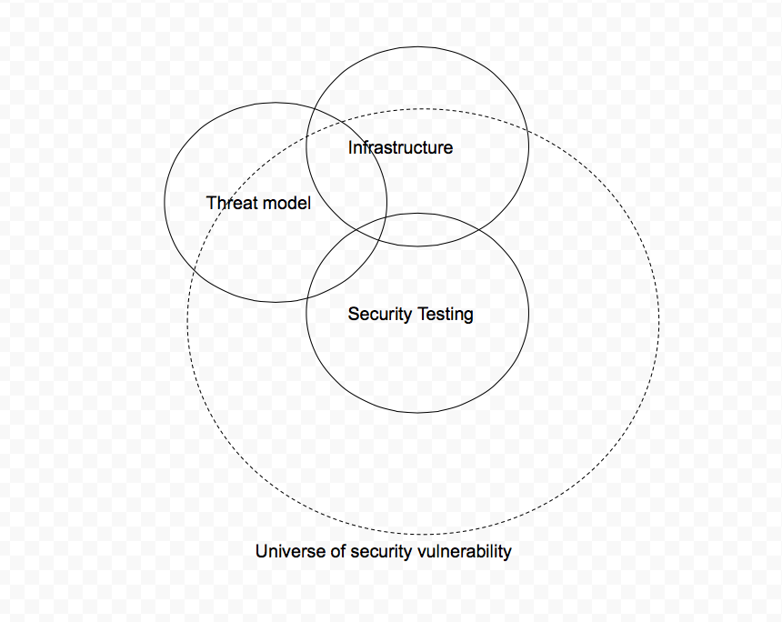
- Fig 1:Venn diagram of threat model process
- An infrastructure that runs efficiently should not waste resources installing protection for non-existent vulnerabilities or threats. This would be analogous to purchasing snake and distributing repellant around your house in a country like NZ where snakes are non-existent except for in zoos and special pet shops.
Ie: I - U = empty set.

Threat model requirements:
- All identified threats are real, so T is a subset of U
- A threat model improves on security testing, therefore T-S=not(empty set)
- A good threat model captures threats and security vulnerabilities that have not been tested by conventional security testing, and are not already mitigated against by the infrastructure. Therefore T-I-S = not(empty set).

Testing
If no strong threat model exists, therefore T-I-S =empty set Ie: it does not add value to security testing.

Figure 1
As we can see from the threat model Venn Diagram, there is overlap between threats captured by our threat model, conventional security testing and mitigated for by the existing infrastructure. In the real world, there are tradeoffs that are made between the needs for security of the software and the practical goals and business needs of designing a solution to a problem[2].

As Shostack contends, threat modeling is not about creating the perfect abstract software[2]. He acknowledges the fact that threat modeling takes place in a real world business and organisations reality where tradeoffs do happen. Threat modeling aims to allow its users to make “better tradeoffs” which are more well informed and ultimately results in more secure designs and software that are compliant with security and business needs[4].

Shostack also breaks the threat modelling process into 4 practical steps that aim to achieve subgoals rather than one continuous task[2]. He states the the questions that we must essentially ask to achieve these subgoals are:

- What are we building/
- What can go wrong with it once its built?
- What should you do about those things that can go wrong?
- Did you do a decent job of analysis? [2]

These steps as the starting points for the threat modeling framework.

2) STRIDE
One of the most popular threat modeling methodologies is STRIDE which is an acronym for Spoofing, Tampering, Repudiation, Information disclosure, Denial of service, Elevation of privilege. Another way to look at it is that it is the exact opposite of everything you want in a secure system, namely Authentication, Integrity, Non-Repudiation, Confidentiality, Availability and Authorisation[2].

Figures 2 and 3 list a full description of the STRIDE definitions and the property that it violates. It also outlines examples of each violation and the typical victims/systems that would be affected by them. In terms of the university of Auckland, we could apply STRIDE to our daily processes as such:

Fig 1: Venn Diagram of threat model structure
Spoofing- Pretending to be someone or something that you are not in order to gain access to a secure area, or a persons Canvas account, marks or exam papers or gaining access to their account to use their library account.

Tampering- A student altering information in the system, for example, changing their mark from a C- to an A+ in the final grading tool.

Repudiation- A student could deny enrolling into a paper or could claim they dropped a paper before the deadline when they did not. If the system does not have effective ways to log actions, then these types of actions can be repudiated.

Information disclosure- This can happen if students are allowed access to someones email or get access to files in Canvas they are not authorised to view.

Denial of Service- A threat agent could flood the university website with requests that would deny real university students access to the services they need.

Elevation of Privilege- This allows an unauthorised person admin access to make changes to another person(s) account or accounts. A person could change a students details, or marks and password in SSO. This could be accidental access given by some flaw in the system or intentional hacking or social engineering to get into an account. .

The STRIDE model is used in a microsoft modeling tool that we will be using to model a “real world solution design” which will be elaborated on in section 5 of this report. I will be doing an analysis on the threat modeling tool to see if it adds value to a security teams objectives and decide if it is effective in accurately modeling and capturing the threats that threaten an organisation.

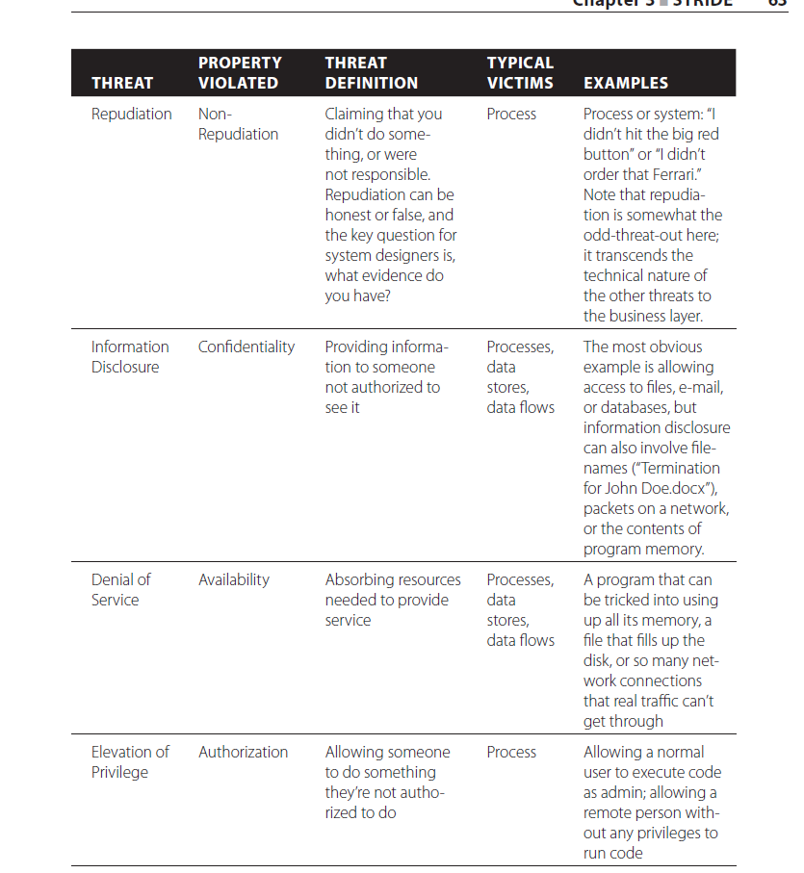
Figure 2[2]
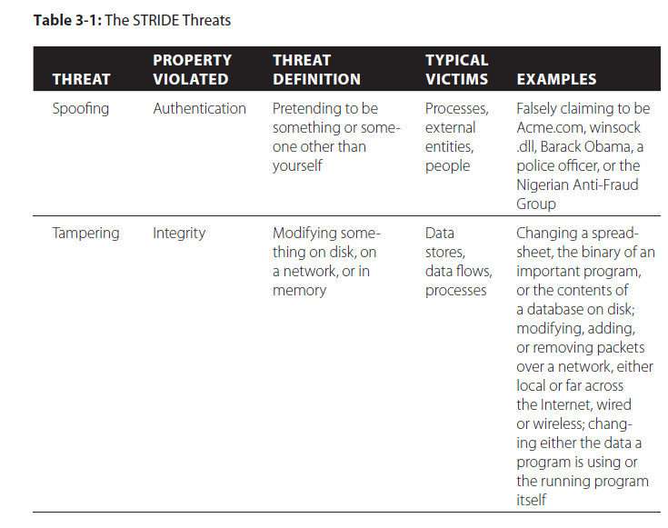

Figure 3[2]

Fig 2 and Fig 3 give a rundown of the STRIDE threats as well as the property violated by those threats, a general threat definition, typical victims of that threat and a few examples of such threats. STRIDE is a well defined threat modeling structure that is simple and easy to understand. There is a vast amount of information on STRIDE on the internet and so information on the topic is readily available to the public. Its non-complexity make it ideal for general use[4].

3) Other Threat Models:
In this section, we will briefly look over some other forms of threat models available for threat modelers to use and we will briefly compare and contrast.

a)DREAD

Dread is another threat model that uses a scale from 1 to 10 to rank each category in its acronym. 1 signifies the smallest probability of that threat to occur and the least damage potential. The rating of each category is then summed up and averaged to get a mean score from the 5 categories to obtain an overall risk rating for each threat. The results can be further subdivided into a high, medium and low risk category[5]. DREAD stands for:

D=Damage = How much damage can this threat potentially cause? This can depend on the context. If the threat can cause your companies main system to crash, then it is given 10 priority. If it causes your companies desktop solitaire game apps to crash, then it is not high priority and may score a 1[5].

R=Reproducibility(also previously known as Reliability)= How often will the attack take place? Is it always successful? Some attacks, such as automated spam email or bots, may be launched at an organisations on a regular basis, but is repelled each time by the network defenses, hence it gets a low rating (1). Other attacks may be orchestrated more cleverly, by hackers or other threat agents, and hit often. These attacks will be given a high rating (9 or 10)[5].

E=Exploitability=How much effort is need to exploit a vulnerability? This section gives a rating to how easy or hard it is to exploit a vulnerability in the system. If you just need web browser acces, this would be very bad and rate as a 10. If you need special authorisation, some type of user authentication, high level access or advanced networking or programming knowledge, then this would be the best case and score a low 0[5].

A=Affected Users=How many users will be affected? This category gives a rating as to how widespread the threat be. How many users will be affected. None=0, some =5 and all=10. Simple one to follow[5].

D=Discoverability=How difficult is it to learn of the threat? Gives rating based on ease of discovering the threat. If it is public knowledge you get a 0, if you need special insider knowledge of the companies system then may need to score a 10[5].

Once the threat has been scored and evaluated for each category, it gets totalled and then averaged to give the final threat score rating. This threat models main criticism is the rating system. The five catergories are mostly independent of each other, in that there is low correlation between them. Therefore the question of how to give weighting to the categories so that it is consistent between them is difficult to do. How do we measure the difference between a 6 and 7 threat rating that has meaning? [5].

The DREAD model is similar to STRIDE in that it makes predictions on potential threats, but its rating system is one of its main points of difference and can be difficult to adequately quantify in a meaningful way. The ratings can be quite subjective depending on who sets up the system.

b) ATTACK TREES
Bruce Schneier, a leading expert in security describes attack trees as “a formal, methodical way of describing the security of systems, based on varying attacks. Basically, you represent attacks against a system in a tree structure, with the goal as the root node and different ways of achieving that goal as leaf nodes”[6].

Attack trees can be seen as an alternative to STRIDE. A diagram is the best way to demonstrate how a threat tree works.

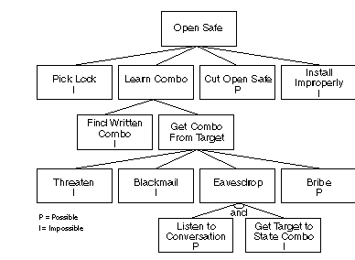
Fig. 4. Threat Attack tree(possibility of attack)[6]

As we can see from the diagram we have a node=”Open Safe” which is the root of the tree and branching off the tree are all the possible ways to open the safe. You’ll also notice that there is an AND statement under eavesdrop node, which denotes that the leaves of that note are a two step process where both actions must be fulfilled[6]. Where you do not see an AND, then by default it is an OR action whereby any one of those leaves branching off from the node is a possible way to accomplish the goal set by its preceding nodes statement. For example, “open safe” can possibly be achieved by “pick lock” OR “learn combo” OR “cut open safe” OR “install improperly”. We can see how this type of security set up has an analog in the I.T world[6].

This particular tree has settings for “impossible” or “possible” for each node, so you can label which options may be impossible or impossible in your tree to get an accurate assessment. Where your tree has OR options, if only needs one of the leaves to be possible in order for the threat to be viable whereas with AND, all leaves of that node must be possible for the threat to exist[6].

The versatility of the threat tree is that it can also be applied across a wide range of categories. For example, “cost of an attack”, or the “need for special equipment” or “need for insider knowledge”. The list is quite broad and can be applied in many contexts[2].

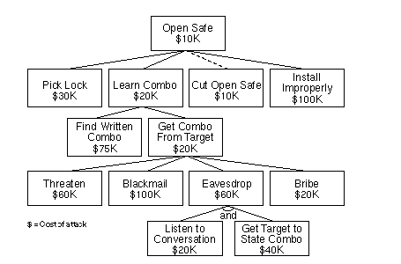
Fig 5. Threat Attack tree(Cost of attack)[6]
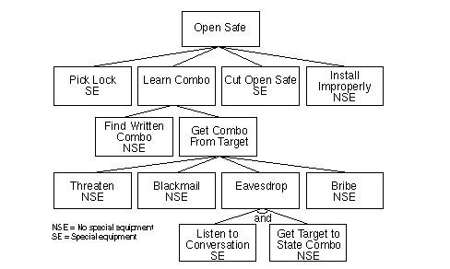
Fig.6. Threat attack trees(Is special equipment required?)[6].

The attack tree is similar to STRIDE based threat model in the way it deals with threats. It takes an individual threat and decomposes it into smaller subsections to express where vulnerabilities may lie. It can be difficult, however, to find completeness in any single tree and this could lead to the exclusion of large attack tree branches that we haven’t considered.

An example here, as stated by Schneider, is that we did not consider the idea of pouring liquid nitrogen on a lock and smashing it with a hammer in our tree, so that threat would not be accounted for, or maybe many others as well (ie: dynamite, drilling etc)[6]. One of his suggestions for finding completeness for attack trees, is to brainstorm using the STRIDE model to find the relevant nodes for the tree.

c) TRIKE

Trike is a threat modeling process based on a risk management perspective. Like STRIDE, it also has a tool that automates threat analysis.

TRIKE is a methodology whereby a threat model is based on the “acceptable risk” that a company or stakeholders are willing to accept for potential threat on each of its assets. Some assets may need carry less importance and so the company would spend less money and time on protecting it while other assets may justify the expense of heavy security.

This needs a “requirements model” that confirms that the risk the asset is assigned is deemed “acceptable” and then a dataflow diagram can be drawn to create an implementation model which includes operation and actions that can be performed in real time[7]. TRIKE goes from a high level architectural design to a low level implementation design.

The final step is the creation of threat models from the analysis of the implementation models. The threats lists are compiled and each threat given the appropriate risk ratings and threat trees/graphs are created with mitigation controls then given for each step that leads to a given threat. Once this process if complete, a risk model is made based on the assets and threat exposure and the roles and action[7].

TRIKE is similar to microsofts STRIDE based model in that it also has a tool that can be applied to a real world design but it is based on risk assessment that not only uses threat models, but also has requirement, implementation and risk models. It also self automates threat trees in its design[7]. Another difference is that it is still in development and thus far has proven to be rather difficult to implement on larger models with more than a dozen entities. It is not as scalable as the microsoft tool.[7]

d) SeaSponge(Mozilla open source threat modeling tool)
This is a new threat modeling tool, created by a trio of university undergraduates. There have been no clinical trials of the tool so far but it is similar to the microsoft tool in that it draws dataflow diagrams and allows you to create threat models. It requires no special add ons or plugins and is quick and easy to use according to reviews. What distinguishes it from Microsoft is that it is platform independent and works on all browsers and operating systems. I will be using this tool in my second report to compare with the microsoft based STRIDE tool which I will discuss in section 4 of this report. Also, the threats must be added manually by the user, they are not auto-generated.

4)Microsoft modeling tool- (STRIDE based tool)
This section of the report will give a very brief outline of how the microsoft based STRIDE tool works and how it analyses and categorises threats, and creates a report from that analysis.

I will be using this tool throughout the rest of the report, so the purpose of this section is to give the reader enough detail about the tool, so that the remaining sections of this report are easy to comprehend.

The microsoft modeling tool allows users to model a real world design using data flow diagrams and predefined trust boundaries to find threats at the earliest stages of the design when changes will be inexpensive. When changes are made after implementation and deployment of the design, changes can be extremely costly. Trust boundaries are the points between entities in the diagram where threats are potentially lurking.

.This tool was recently updated from a 2014 version to the current 2016 version we are using today. This shows that microsoft firmly believe in the threat modeling process. As per the microsoft threat tool “getting started” manual, the threat model tools allow the user to:

· 1) Use easy drawing environment for web architecture modeling.
· 2) Generate automatic threat generation that utilises the STRIDE per interaction approach.
· 3) Define own template for your threat model
· 4) gives user the option to add their own user-defined threats
Starting at 1) begins with a drawing environment as seen below where we have different entities we can select, and different types of dataflows between them as well as select processes, external entities, trust boundaries and databases.
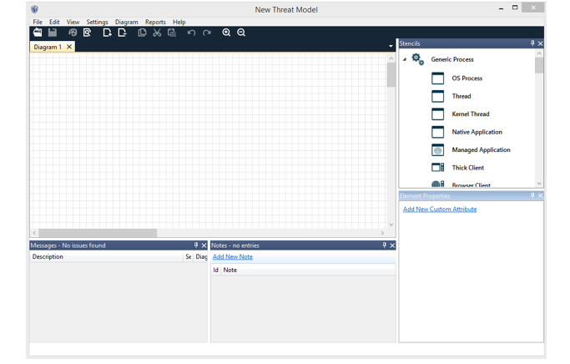

Fig. 7
This is drawing environment for the threat modelling tool.
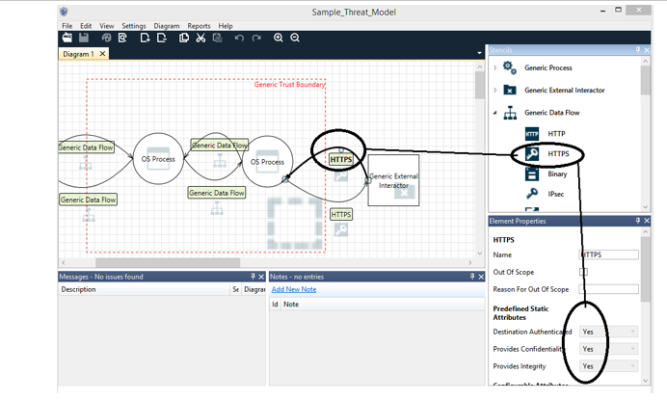
Fig 8
We can look at 2) now once the threat model has been constructed. We can switch from design view to analysis view and this immediately generates a list of possible threats using STRIDE per element. STRIDE per element refers to the application of the STRIDE threat catergories to the dataflow between two entities on the drawing board(ie: server and database or application and server) which is defined by the trust boundary we draw between them.
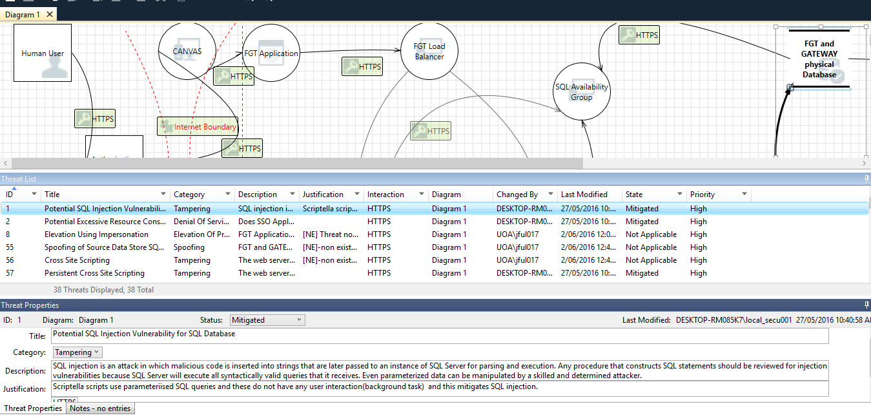
Fig. 9.
As we can see in the diagram, a list of 38 threats are generated and all of them have been automatically categorised according to the STRIDE class of classification. This is very useful for our threat model because it tells us exactly what type of threat needs to be mitigated against in the network.
I have highlighted one of the threats and the tool then highlights the “element” or dataflow connection between the two entities concerned, as shown in the diagram, that corresponds to that particular threat. The user is then required to mark the threat as either:
- Not started
- Mitigated
- Not applicable
- Needs investigation
If it has been mitigated against already by the infrastructure, as seen in the diagram pictured above, we also need to enter a justification for that mitigation for analysis purposes.
The tool also allows the user to categorise the threats as high(default), medium or low priority status via a dropdown box to add more accuracy to the threat model.
Once we have gone through all the threats and applied these steps, the final step is to generate a report by clicking on the reports tab at the top of the screen and choosing either a full report or a custom report.
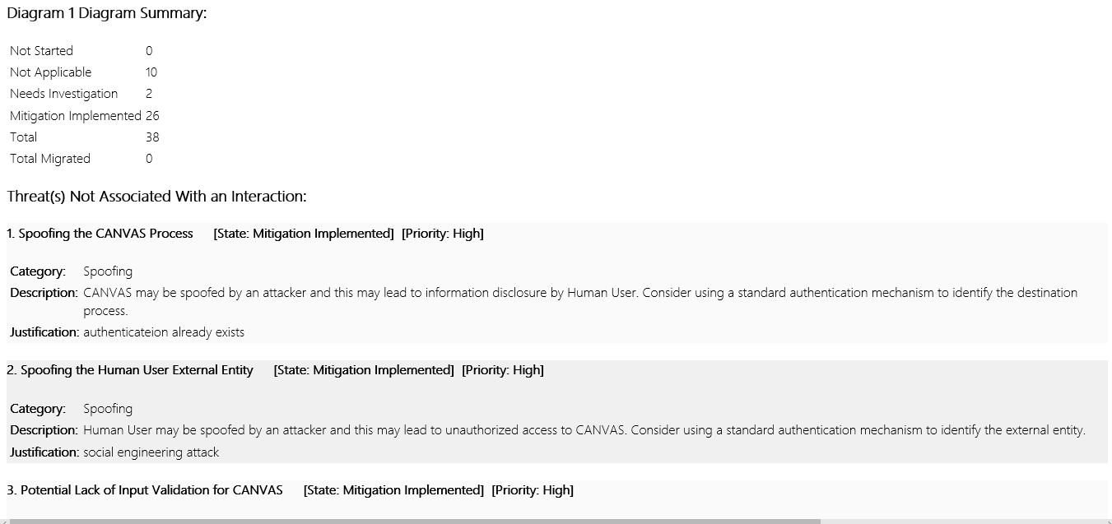
Fig 10. [Typical example of a page in the full report]
BTECH451 Project:
5) Real world application- Applying threat modeling to web architecture
In this section of the report, we will be examining the results of a preliminary trial run of threat modeling on a real world architectural solution design. I will be working for I.T.S who oversee all internet related jobs and services for the University of Auckland. For my project, I have been assigned the task of creating a threat model on a solution design for an application that the university will be using. Due to the need for confidentiality, specific details of the application and its use will remain anonymous, and so I will be using generic names for the systems and entities in the threat model.

I will be using the microsoft modelling tool described in section 4 to model the real world application as closely as possible to the real physical application model. The models are designed by the web architects with a high level of abstraction. Their high level architectural designs give a good overview of the entire system, breaking it into smaller parts or entities that represent how the design works, and fits together with other parts, in providing a solution. A singular entity on a high level design may represent a database, for instance, that serves a certain function in the solution design. In the physical world, however, this one entity could consist of several load balancers, and/or several servers.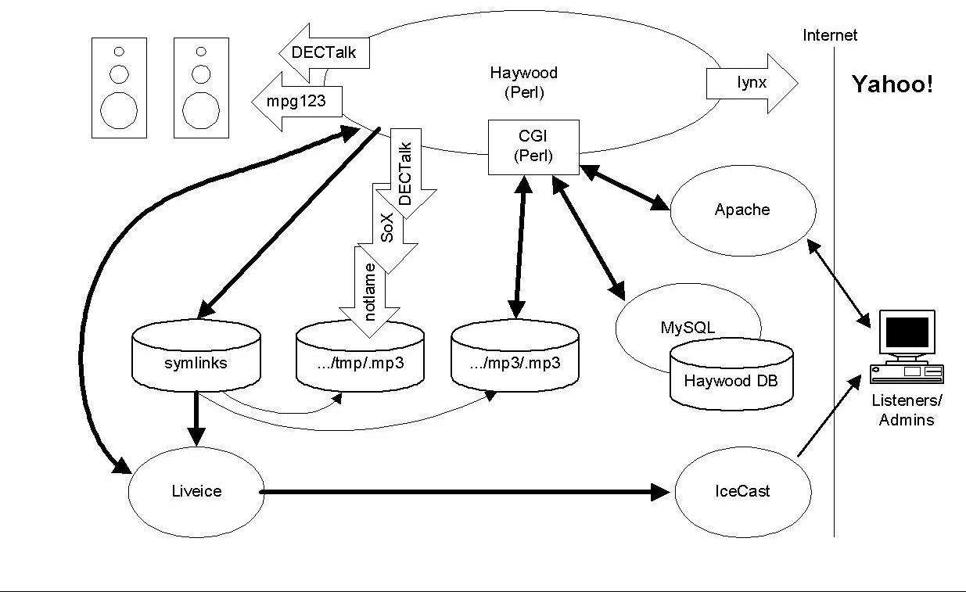
Fig 10.rhew.org (c) 2001 James Rhew –example of high level design from google images

The microsoft STRIDE based tool works on the OSI layer 7 which makes it easily adaptable to the physical representation of the high level designs. In the first cut of my threat model, I have worked closely with the web architects of the app, to model a very close approximation to the physical components of the high level design. For this preliminary first cut model, I eliminate the abstraction and make it as detailed as possible in order to make it fit its physical representation. The aim is to model our tool as accurately as possible. Theoretically, this should make it a “good model” and give us the most accurate results. One experts states “There are no good models, only useful ones”[2].

When applying the threat model to the application we are to analyse, we should also keep in mind the 4 steps for the threat modelling process mentioned earlier:
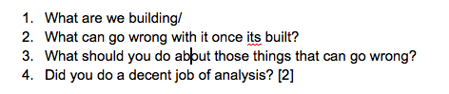
We want to ensure that we always have these steps in mind as we analyse any program or model. Due to the confidentiality agreement, I cannot mention what the application I am modeling is used for, but I can say that it will be used by thousands of students so it is very vital that it is secure and safe.

Looking back to the Venn diagram in 1A, ultimately what we want is a model that fits the criteria we set out. This report will also assess the validity of that criteria as we test and analyse our model for flaws and weaknesses. We may find that the model does not fit the criteria and so by definition of that criteria, it must be a “bad model”. We then have some alternatives and additional steps to take in our process.

Process for threat model evaluation:
- We continue with the STRIDE based microsoft model and tweak it until we get a favourable result that fits our criteria and so provides us with a good model, by definition of that criteria.
- STRIDE based model does not fit the criteria given, no matter how we tweak the model, so we abandon the microsoft modelling tool and try an alternate threat modeling tool (ie: OWASP, Seasponge)
- Alternatively, after an analysis on different models and their performance, we could arrive at the conclusion that the criteria is not robust and needs amending (ie: there are better ways to do it).

To date, very few empirical studies have been done on threat modeling and STRIDE in order the measure and quantify its actual value to an organisation. 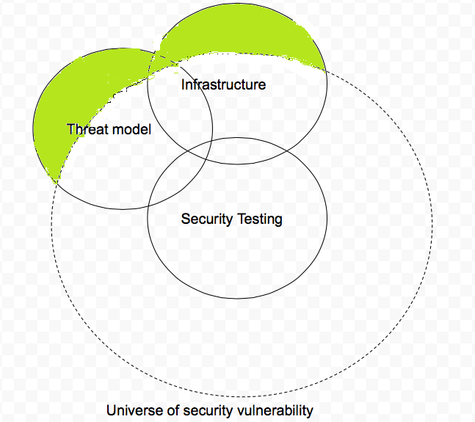

Figure 12 (Threat Model where identified threat do not exist)

Using our Venn diagram, we can formalise our criteria for a good model as such:

- A threat model does not introduce non-existent vulnerabilities: T - U = empty set{}

- An efficient infrastructure should not provide protection against non-existent vulnerabilities, hence: \diamond (I - U = \O)-(we will not consider this in threat modeling.)

- [Possibly] Security testing does is specific enough to not test infrastructure provisions, hence T \cap I =empty set{}

- Threat model requirements

  - All identified threats are real, hence T \subset U=T-U = empty set {}
  - A threat model improves on security testing, hence: T - S -I = not empty set{}
  - A strong threat model identifies security vulnerabilities not tested and not covered by infrastructure, hence T-I-S = not empty set{} (but all part of U! As per req 1)

The above Venn diagram threat model represents a threat model that includes threats that do not exist. In other words, they capture threats that are not within the universe of security vulnerability.

It also shows that the infrastructure also guards against non-existent threats. It violates criteria 1 and 2 of our threat model criteria.

For this report on threat modeling, we will not concern ourselves with criteria 2 as this involves infrastructure which we are not concerned with for now. Our primary concern is our threat model.

If the threat model captures threats that do not exist or are nonsensical, we can assume we have a “bad model”. It would result in security spending time and resources chasing ghosts so to speak, which results in money wasted.

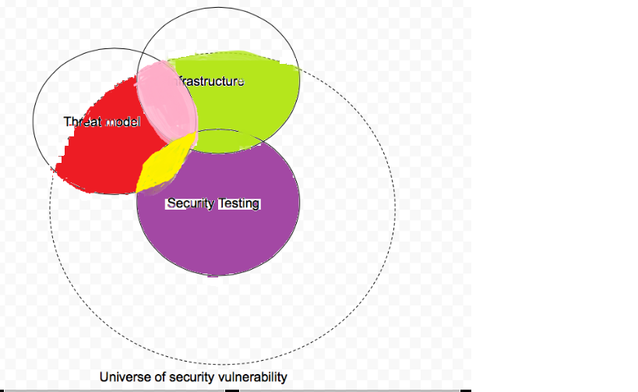
Figure 13(Ideal threat model coverageThe threat model above is the ideal threat model we are looking for. It improves on security testing, captures threats not covered by the infrastructure, and all the threats are real. (ie: S-T=non empty set{} AND T-I=non empty set{} AND T-U=empty set{}.

When we model the real world tool which is currently used by the University of Auckland, we will be testing to see if the microsoft STRIDE based threat model captures threats that are not already mitigated against via the infrastructure, or been tested or mitigated against via the current security testing processes.

This is what is called a STRIDE based gap analysis, whereby we aim to find the gaps in the security. According to our set criteria 4b for a “strong threat model”, if we have modelled it well, the threat model will add value to the security process and find the “gaps” in the testing and hence find vulnerabilities in the design since T - S -I = not empty set{}.

This leads us onto section 6 of this report where we conduct our analysis of the current architecture design via STRIDE gap analysis.

6) STRIDE based gap analysis on a solution model

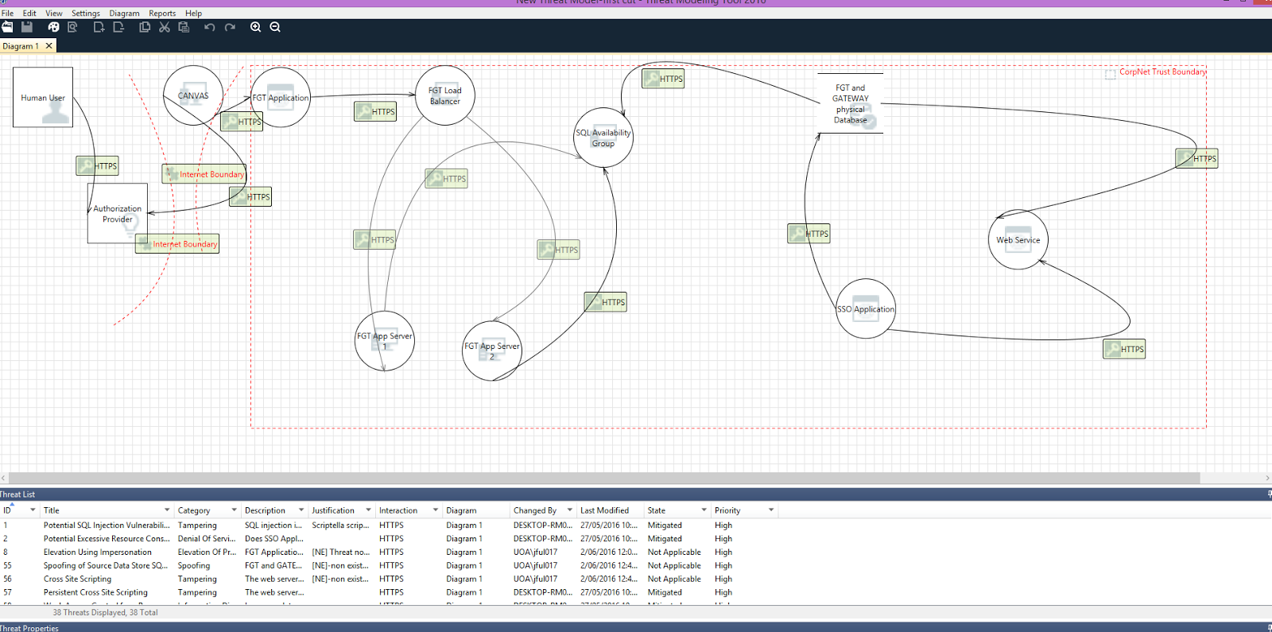
Figure 14[First cut of threat model)

This report has given a detailed description of how the microsoft STRIDE based tool works. In section 4 of this report, a detailed description of how the entities can be selected, connected, and simulated are given, as well as the ways in which trust borders can be drawn between entities. It goes on to detail how the threats are subsequently categorised in terms of STRIDE, before being presented for analysis. As previously mentioned, the user then has the option of marking it as either ‘mitigated’, ‘needs investigation’, ‘not applicable’ or ‘not started’.
.
With assistance from the security team based at I.T.S, a STRIDE based gap analysis is performed using the microsoft tool. The idea is to begin our analysis by comparing the results of the STRIDE based tools findings with that of the findings of the security teams current testing practices. This is accomplished by firstly, going through the threat models list of captured threats, removing those that are already mitigated against via the infrastructure and then comparing the remaining threats with the current security reports findings. According to the criteria we set for a “strong threat model”, the results should be T - S -I = not empty set{} (Criteria 4B) as we have already stated that a threat model adds value to security testing.

In figure 14, with collaboration from the application design team, I have made a first cut model of the university application. It was very detailed and all abstractions from the higher level design were removed to ensure we had an accurate model representation of the physical real world application.

In the high level design as shown below, you will notice there are fewer entities present. This is because there are several entities in Figure 14, the physical representation, that are represented by one entity in the high level design. High level design is a class diagram at a conceptual level with high abstraction, with no operations defined as such, while the microsoft tool is ideal for implementation level and can be described a low level design tool. It is versatile enough, however, to model in a more abstract way, as we will find in the later cuts of threat model.
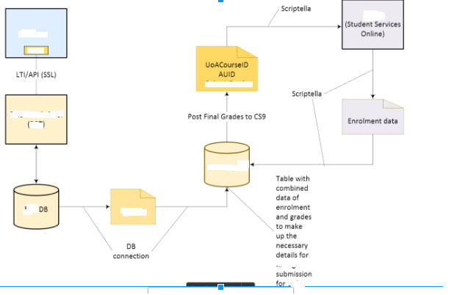
Figure 14a) High Level design of the real world application tool

Depicted in figure 14a, is the high level design for our real world application tool for the university of auckland. For security reasons and in line with a confidentiality agreement, I have erased the specific names of the entities. The blue box entity represents a platform used by all university students. It communicated with the yellow box entity which is the application we are modelling, then that application connects to its application database which also connections to a main database. This data is then transferred to student services online where it must be authenticated with UoaCourseID and Auid and combined with enrolment details before the data is finalised and made available on Student Services Online(SSO).

This high level design does not show the details of implementation, such as the transfer from the real world application to its database having to go through a load balancer and then two separate servers etc. These details and others like it, are omitted from the diagram at the high level.

In our first cut of the microsoft STRIDE based threat model as shown in Figure 14, we have the human user that connects the blue box platform, which then connects via https to the real world app. Thus far, the microsoft STRIDE based threat model, but from here onwards is where we see the two models differ.

Instead of connecting to a generic database, the microsoft model connects to a load balancer, which then branches off into two separate servers (that represent the real world app database in the high level design). Next we see a dataflow from here to an SQL availability server that serves as a load balancer for the 2nd database in the high level design.

Note that the load balancer and two servers are abstracted into one database in the high level design. The SQL server is also not present in the high level design. Also, we can see that in our physical representation of the app in the microsoft tool, that the two separate databases are actually one single physical database at the implementation level.

1st run of threat model from Fig 14)(1st cut threat model):
The results showed that the threat model picked up 38 possible threats:

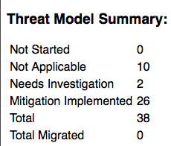
With the aid of a security team member, we went through each threat per STRIDE category and marked it as either already mitigated against by the system (Mitigation Implemented), not started, needs investigation and not applicable which in this instance, meant the threats were non-existent because they made no sense.

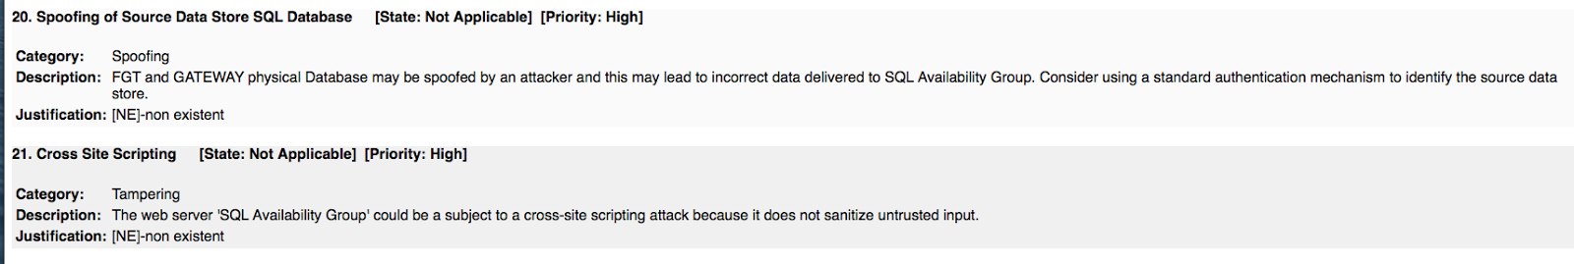
Figure 14c) Excerpt from threat modeling report analysis

For example, the threat for 20. is non-existent because the SQL Availability Group is a load balancer and the app database does not communicate back to it.

We find two threat that were categorised as “needs investigation” and which were not tested or captured by the conventional security methods. Since the model violates the first criteria, however, a reconfiguring of the model is needed to ensure that results are accurate. From this perspective, our gap analysis was successful as we were able to identify two potential threats that conventional security testing did not detect.

At this point, however, we can see that our model violates the 1st criteria of our concept of a “good strong model” because our model finds non-existent threats. This development means it casts doubt on any analysis from this point forward so we refer back to process for threat model evaluation, step 1.

1)We continue with the STRIDE based microsoft model and tweak it until we get a favourable result that fits our criteria and so provides us with a good model, by definition of that criteria.

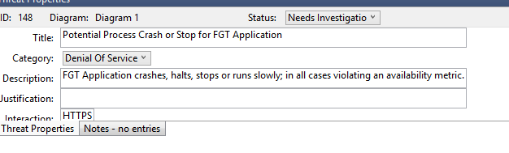
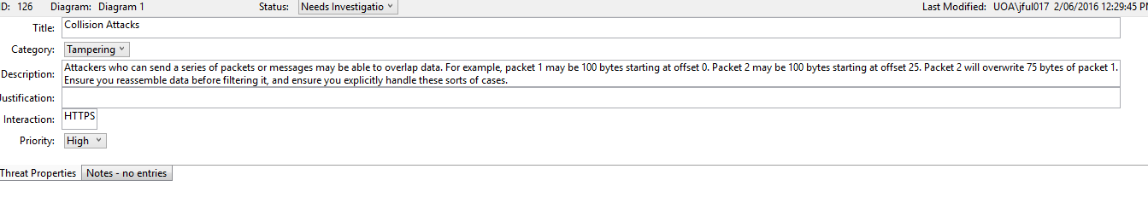
Fig 15)(two threats not tested by security team)

With advice from the security team expert, we determined that we may need a certain level of abstraction in our model to eliminate these non-existent/nonsensical threats from the threat model report.

This is due to the fact that many of the NE(non existent threats) resulted from false interactions between two entities that do not communicate directly, and perhaps the inclusion of too much detail in the model leads to these false flags.

Even though this hypothesis is supported by a data analyst from the security team, it must be taken with a grain of salt, as we are still in the process of experimenting with the model and fine tuning it.

Shostack states “Threat modeling is first and foremost a practical discipline….To use an analogy, when you start playing an instrument, you need to develop muscles and awareness by playing the instrument. It won’t sound great at the start, and it will be frustrating at times, but as you do it, you’ll find it gets easier”[2].

Hence the threat modeling process is by his admission a trial and error process where we learn how to model it properly along the way. It must be approached scientifically with a rigorous step by step process where we will modify our design by changing only one thing every time, so we can isolate the problem.

Currently we have 10 NE and we want to modify our design until we have no NE. It is possible we solve this issue and get another violation of our criteria appear and we will have to repeat the scientific process of test, redesign and analyse.

Another possible result of this process, as mentioned in section 3, is that we may find that an evaluation of the criteria itself may have to be conducted, if the results continue to be in violation of any of the criteria we first set out for our threat model. It may need to be amended if continuous redesigns yield the same results. This may be something we look at in part 2 of this report, which is due at the end of semester two.

According to Shostack, in certain situations “Using a model means abstracting away a lot of details to provide a look at a bigger picture”[2]. For the second and third cuts of the modelling tool, I abstracted away the load balancer for the two servers(second cut) and the SQL load balancing server(third cut) and also abstracted away the two servers as one single server(as per high level design) as these were the cause of the some of the NE threats according to our security expert.

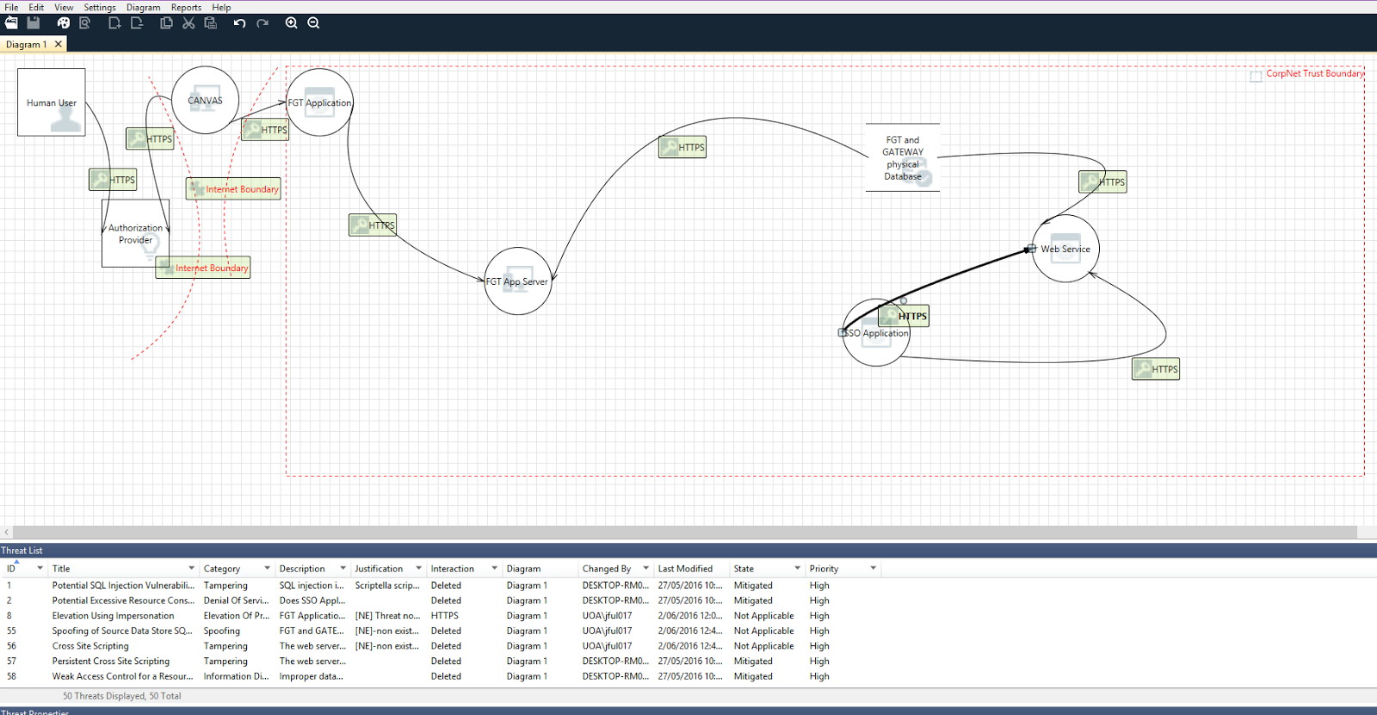
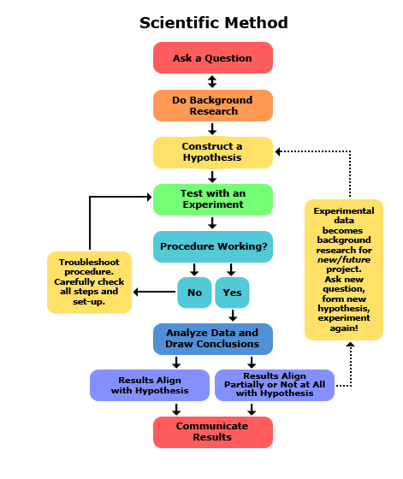
These changes, however, did not change the number of NE threats. In fact, they actually added more threats to the list. We had 38 threats in the first cut and this was increased to 42 by the second cut, 44 by the third cut and 47 by the fourth cut. The NE threats did not disappear and it is possible that more of them emerged.
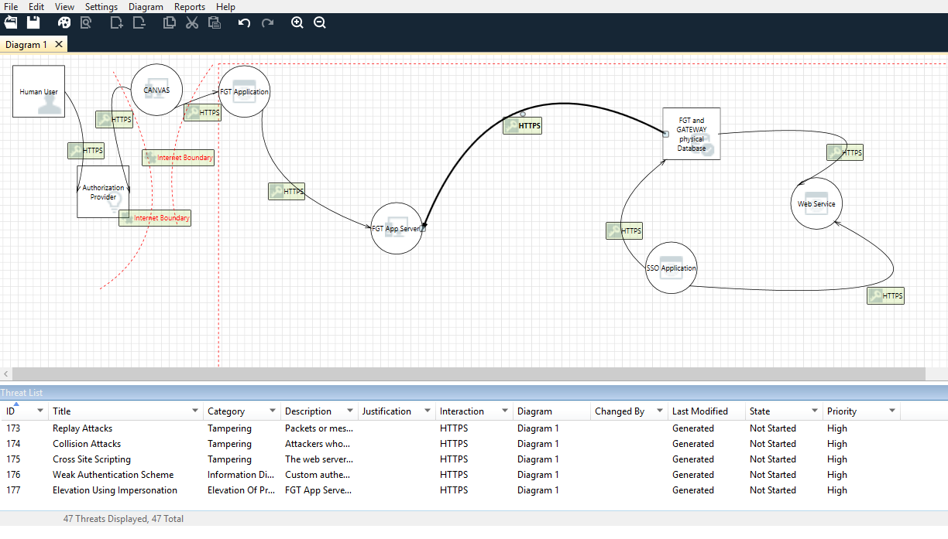

Figure 16(fourth cut of draft model)

In the fifth cut of the threat model, I tried changing the dataflow between SSO to the FGT database since I received information is communicated non-directly through a web service(scriptella). This also failed to reduce the NE threats and added an additional 12 threats(50 threats total).

Figure 17(5th cut of draft model)

This ends our trial run experiment with the threat model and this app for now, but I will be looking at trying different approaches with the formulation of the microsoft model in the next report, which needs more consultation with the designers of the real world application and the ITS security team.

I will also be doing trial runs of the Mozilla seasponge threat tool, which is a new open source threat tool that has been designed with the aim of replacing the microsoft threat modelling tool. It is not yet able to generate automated threats, as each threat needs to be manually added by the user, but it will be useful for applying different threat models such as STRIDE and TRIKE to the tool. Seasponge is also platform independent which is handy and since its opensource and still in development, automated threat generation could have been enabled by the time I use it next semester. 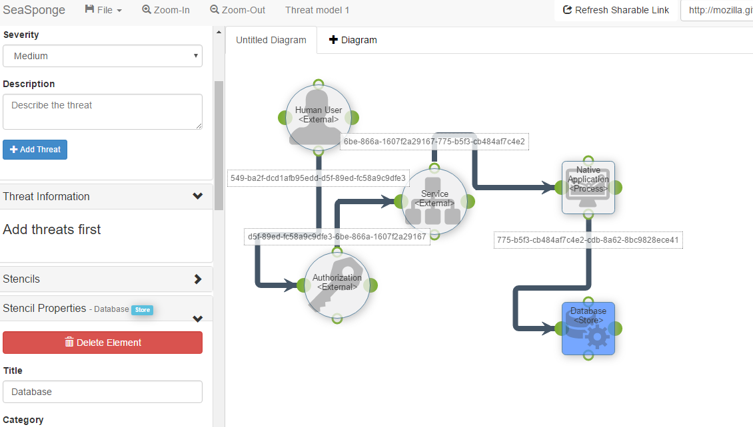

Fig 18 (Mozilla Seasponge threat modeling tool-Open Source and platform independent)

7) Preliminary results and recommendations
In this particular case,adding abstraction to the model did not seem to resolve the issue of NE threats. In each case the NE threats not only remained the same, but even more threats were added to the list as a result.

In summary, we began with a model that was modeled to be fitted as closely as possible to the actual physical representation of the real world application. I consulted with the designers of the model to to confirm that the details of my model were accurate. It was detailed with no abstraction and was what we call a low level implementation model.

It resulted in 10 NE threats which immediately tells us that we have violated criteria 1 of our rules around what constitutes “a good model” therefore its results would be questionable based on our criteria. Four subsequent redesigns with incremented abstraction failed to remove these NE threats and added more threats where some of them could also potentially be NE threats. I would need to consult with the security expert on this to be certain.

However, if we ignore criteria 1 of our threat model analysis, and accept that the threat model may sometimes generate false flags,and maybe quantify a tolerance threshold for a number we are willing to tolerate, then the results of our gap analysis are positive, as it revealed two possible threats that the conventional security checks did not detect.

There is certainly a case for this to be amended, as we also pick up threats that the security team can see as already being mitigated against by the infrastructure, and which they mark as “mitigated”. 10 NE threats would not take long for security to filter out and discard, so I would recommend deciding on a threshold for these occurrences.

Model | Diagram | Criteria 1 | Criteria 2 | Criteria 3 | Criteria 4
Microsoft  STRIDE Tool | First cut | NO
Microsoft  STRIDE Tool | Second cut | NO
Microsoft  STRIDE Tool | Third cut | NO
Microsoft  STRIDE Tool | Fourth cut | NO
Microsoft  STRIDE Tool | Fifth cut | NO
Fig 19: Criteria for good threat model. Since first criteria violated=no need to check others.
8) Conclusions
In this report, we have discussed the importance of having threat modeling in an organisation. We have discussed how threat modeling can add value to a security testing process and how it can aid web designers by finding threats early on in the design process before implementation, which allows them to mitigate or amend designs early on, and saves on costly changes after the fact. We have also defined the threat model in terms of a venn diagram, and have set criteria using that diagram to define a good model, or in other words, a model that can be used. This report has also discussed STRIDE and alternative threat model methodologies and tools.

In the experiment portion of the report, we applied the threat model to a real world application used by the University of Auckland. Using high level designs we modelled the design at a low level implementation stage with details closely resembling the physical representation of the application and its interactions within the network with databases and servers. As mentioned previously in section 7, our model violated criteria 1 for a good model, so we redesigned 4 more times, each with added level of abstraction. This did not solve the issue of of NE threats, but I reasoned that if we ignored this criteria partially by perhaps creating some threshold for the NE threats that we would deem acceptable, then its results of our gap analysis would be successful in finding two additional threats the infrastructure and security testing had missed (ie: T-I-S =not empty set) therefore the model adds value to the security testing process.

In conclusion, this particular threat modelling tool needs more investigation and experimentation. I cannot conclusively determine at this time exactly what the results may mean, but from this experience I have learnt that despite the tool being promoted as being easy to use by non experts, it still needs someone with specialised security knowledge of the system or network to analyse the findings of the tool. At this time, I do not believe that the average web architect,without in depth security knowledge, would be able to use this tool as it is at the moment. They would need specialised training in security and knowledge of how to mitigate threats or how to recognise whether a threat has already been mitigated by the infrastructure, as this information is not obvious to the layman. Hence this tool, in my opinion, is best used by security.

It is still a valuable tool for the architects, but it is best used by the security team who can then pass the recommendations onto the architects for their designs. It may be best to have a process whereby the web architecture teams send the drafts of their designs to the security teams or a specialised threat modeller during the early design stages, and they could possibley do the modelling of the design for them and send back the feedback at that early stage so they can make amendments or improvements to their design early, while changes are inexpensive.

I will be taking some security based courses next semester and this should help me use this tool more efficiently also, without needing as much help from the security team. I will continue to test this tool with the real world app and match it up against other threat modelling tools such as seasponge. Using these results, we can make detailed comparisons between the different threat modeling tools in part 2 of this report. The challenge will be how to find a process that can be suited to both teams and bridges the gap between the lack of security knowledge in web architecture that is a barrier to their use of this threat modeling tool, and the allocation of time for a busy security team to have someone do additional work in threat modelling the architectural designs. Part 2 of this report will attempt to find a practical solution to these problems, as well as continuing to research and experiment with microsoft STRIDE and different threat models to find which gives best value for our case.

Acknowledgements:
I would like to thank the security team and web architect teams at I.T.S for their assistance with my project.

Bibliography:
[1]P. Karger and R. Schell, "Thirty years later: lessons from the Multics security evaluation", 18th Annual Computer Security Applications Conference, 2002. Proceedings..

[2]A. Shostack, Threat modeling. .

[3]R. Scandariato, K. Wuyts and W. Joosen, "A descriptive study of Microsoft’s threat modeling technique", Requirements Engineering, vol. 20, no. 2, pp. 163-180, 2013.

[4]P. Torr, "Demystifying the Threat-Modeling Process", IEEE Security and Privacy Magazine, vol. 3, no. 5, pp. 66-70, 2005.

[5]"DREADful", David LeBlanc's Web Log, 2007. [Online]. Available: https://blogs.msdn.microsoft.com/david_leblanc/2007/08/14/dreadful/. [Accessed: 04- Jun- 2016].

[6]"Academic: Attack Trees - Schneier on Security", Schneier.com, 2016. [Online]. Available: https://www.schneier.com/academic/archives/1999/12/attack_trees.html. [Accessed: 05- Jun- 2016].

[7]"Comparison of Threat Modeling methodologies", MyAppSecurity, 2012. [Online]. Available: http://myappsecurity.com/comparison-threat-modeling-methodologies/. [Accessed: 05- Jun- 2016].

[8]F. Hommedal, "CSIRT Modeling", Frodehommedal.no, 2016. [Online]. Available: http://frodehommedal.no/presentations/first-tc-oslo-2015/#/slide-start. [Accessed: 06- Jun- 2016].

[9]P. Kim, The hacker playbook 2. .

